**Horizontal Scalable SaaS Simulation:**

* The datacenter contains 6 hosts and 2 VMs. The user requests to run 10 cloudlets.

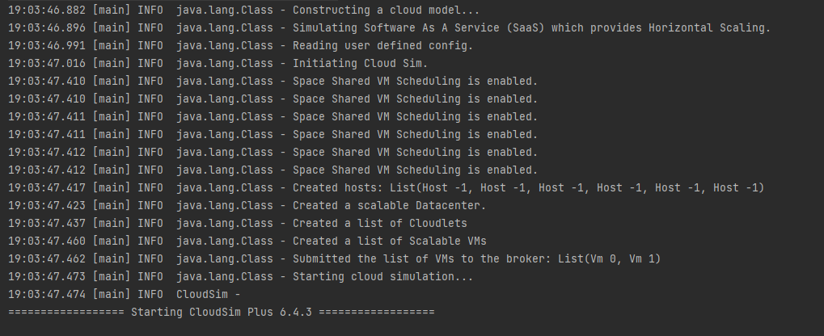

* Since there are less VMs to completely accommodate the request of 10 cloudlets, the horizontal scaling (scale out/increase in number of VMs) takes place.

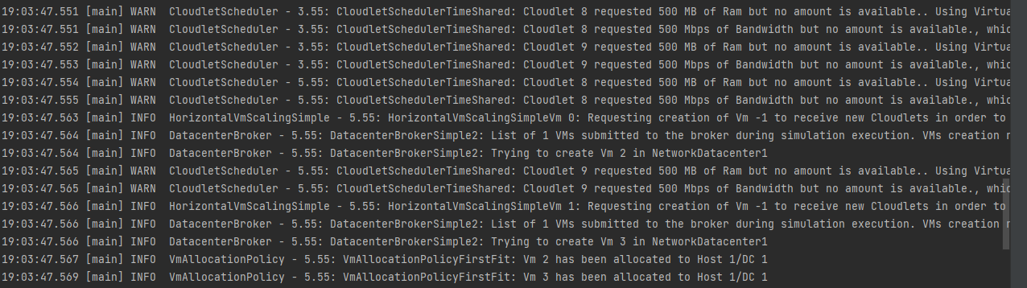

* The run finishes with 2 extra VMs being created, to accommodate the request of 10 cloudlets.

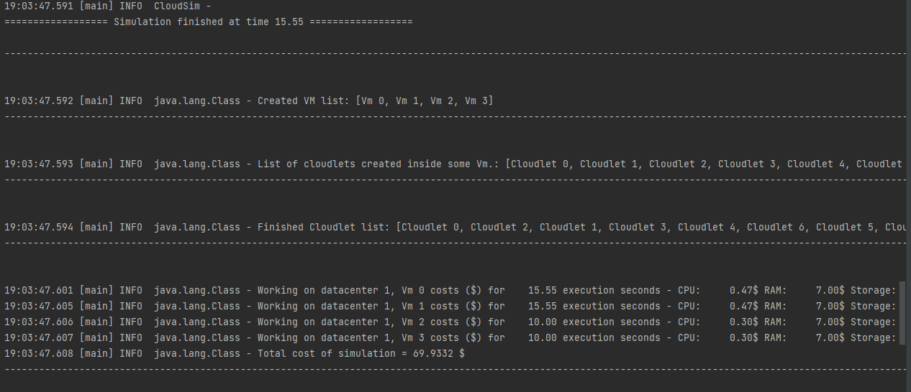

* The final execution summary of the 10 requested cloudlets.

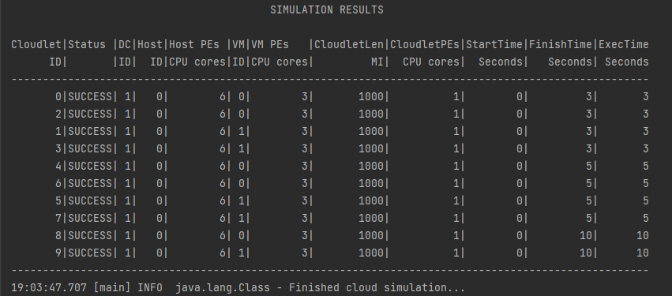

**Space Shared VM Scheduling Simulation:**

IaaS with Space Shared VM scheduling and First Fit VM Allocation Policy, with Utilisation ratio set to 0.7. Each cloudlet runs while taking the resources fully, once that cloudlet finishes running, the other one starts.

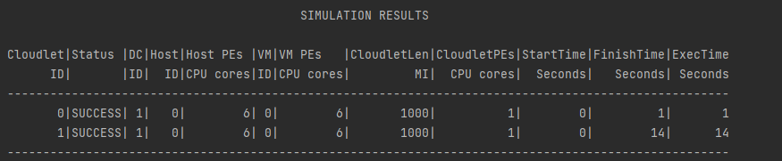

**Time Shared VM Scheduling Simulation:**

IaaS with Space Shared VM scheduling and First Fit VM Allocation Policy, with Utilisation ratio set to 0.5. Both the cloudlets start utilizing the resources in parallel, thus taking longer time to finish.

Round Robin scheduling also uses Time Shared VM scheduling.

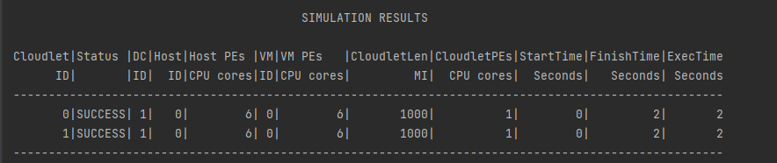

**Multiple Datacenter Simulation:**

3 different types of Datacenters are submitted to the broker. The datacenters are connected to each other using the Brite topology.

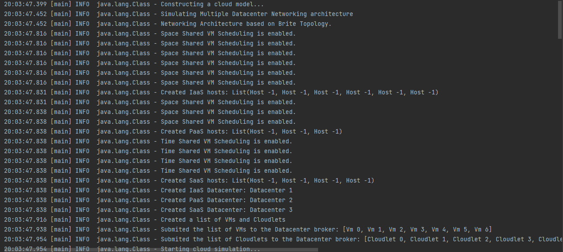

**General Observations:**

* UtilizationRatio impacts the execution time, there were instances when the Execution time was really really high for some cloudlets.
* When the number of hosts in the Datacenter were less than the number of VMs requested, the simulation went into an infinite loop as there were less resources in the data center than requested.
* FaaS (Function as a Service) is a special case of Platform as a Service, thus the PaaS model can itself be utilized for the same.
* The cost of execution, which depends on the time duration of the execution, memory, storage and the bandwidth used during the execution, plays a vital role in selecting a service provider. Datacenters with same number & configurations of VMs & hosts can provide different Total cost.
* VM allocation policy and VM scheduling policy can be played around with and be provided in any combination. It is a trade off between cost and time that eventually leads to the selection of one type of policy over the other.

**Future Enhancements:**

* In case of multiple Datacenters, multiple brokers can be simulated in order to send VMs to respective datacenters, thus optimizing the utilization of the datacenters.
* Vertical scaling/Scale up/down can be implemented and be compared with Horizontal scaling, to see the difference in execution time & cost.
* Cloudlets can be mapped to certain VMs, thus allowing them to be run on only those VMs. This can be done for specific cases, where the cloudlet needs heavy resources.